Module 3 - PL/SQL Programming
Exercise 1: Control Structures

Creating Tables:

Customers Table:

CREATE TABLE Customers (
CustomerID NUMBER PRIMARY KEY,
Name VARCHAR2(50),
Age NUMBER,
Balance NUMBER,
IsVIP VARCHAR2(5)
);

Loans Table:

CREATE TABLE Loans (
LoanID NUMBER PRIMARY KEY,
CustomerID NUMBER,
InterestRate NUMBER(5,2),
DueDate DATE,
FOREIGN KEY (CustomerID) REFERENCES Customers(CustomerID)
);

Inseting data:

Customers Table:

INSERT INTO Customers VALUES (101, 'Ravi', 65, 15000, 'FALSE');
INSERT INTO Customers VALUES (102, 'Priya', 45, 8000, 'FALSE');
INSERT INTO Customers VALUES (103, 'Amit', 70, 20000, 'FALSE');
INSERT INTO Customers VALUES (104, 'Neha', 30, 5000, 'FALSE');

Loans Table:

INSERT INTO Loans VALUES (201, 101, 8.5, SYSDATE + 15);
INSERT INTO Loans VALUES (202, 102, 9.0, SYSDATE + 45);
INSERT INTO Loans VALUES (203, 103, 7.5, SYSDATE + 20);
INSERT INTO Loans VALUES (204, 104, 8.0, SYSDATE + 10);

COMMIT;

Scenario 1: The bank wants to apply a discount to loan interest rates for customers above 60 years old.
- Question: Write a PL/SQL block that loops through all customers, checks their age, and if they are above 60, apply a 1% discount to their current loan interest rates.

Program Code:
DECLARE
v_age CUSTOMERS.AGE%TYPE;
BEGIN
FOR cust IN (SELECT CustomerID, Age FROM Customers) LOOP
v_age := cust.Age;
IF v_age > 60 THEN
UPDATE Loans
SET InterestRate = InterestRate - 1
WHERE CustomerID = cust.CustomerID;
DBMS_OUTPUT.PUT_LINE(
'1% discount applied for Customer ID: ' ||
cust.CustomerID
);
END IF;
END LOOP;
COMMIT;
END;
/
Output:
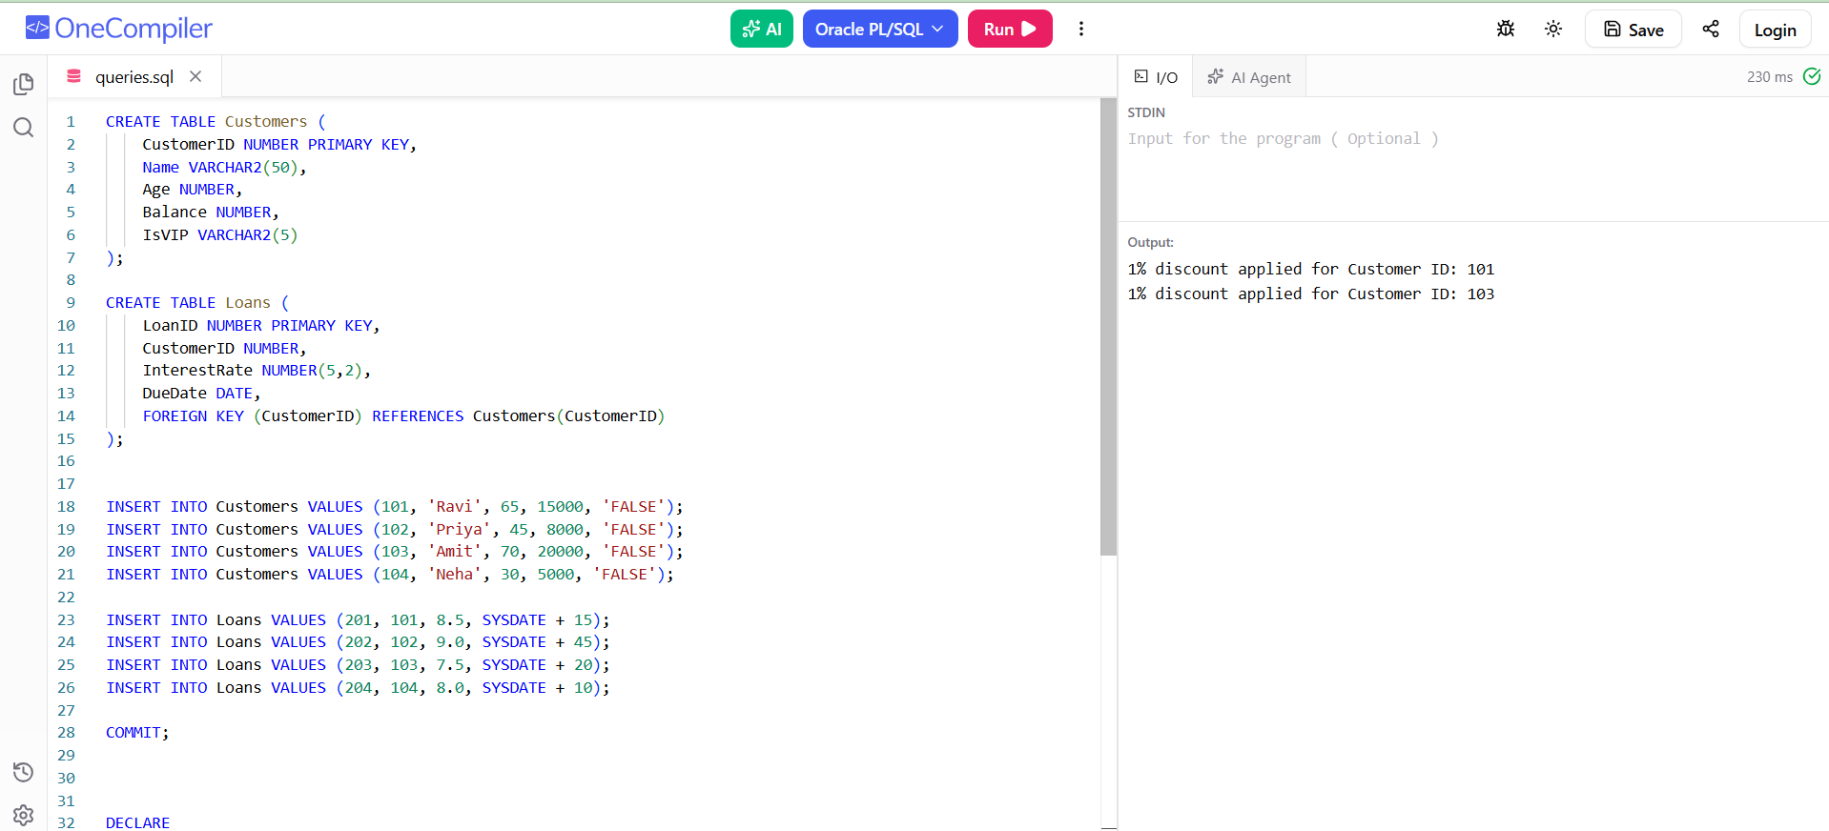

Scenario 2: A customer can be promoted to VIP status based on their balance.
- Question: Write a PL/SQL block that iterates through all customers and sets a flag IsVIP to TRUE for those with a balance over $10,000.
Program Code:
DECLARE
BEGIN
FOR cust IN (
SELECT CustomerID, Balance
FROM Customers
) LOOP
IF cust.Balance > 10000 THEN
UPDATE Customers
SET IsVIP = 'TRUE'
WHERE CustomerID = cust.CustomerID;
DBMS_OUTPUT.PUT_LINE(
'Customer ID ' || cust.CustomerID ||
' promoted to VIP.'
);
END IF;
END LOOP;
COMMIT;
END;
/
Output:
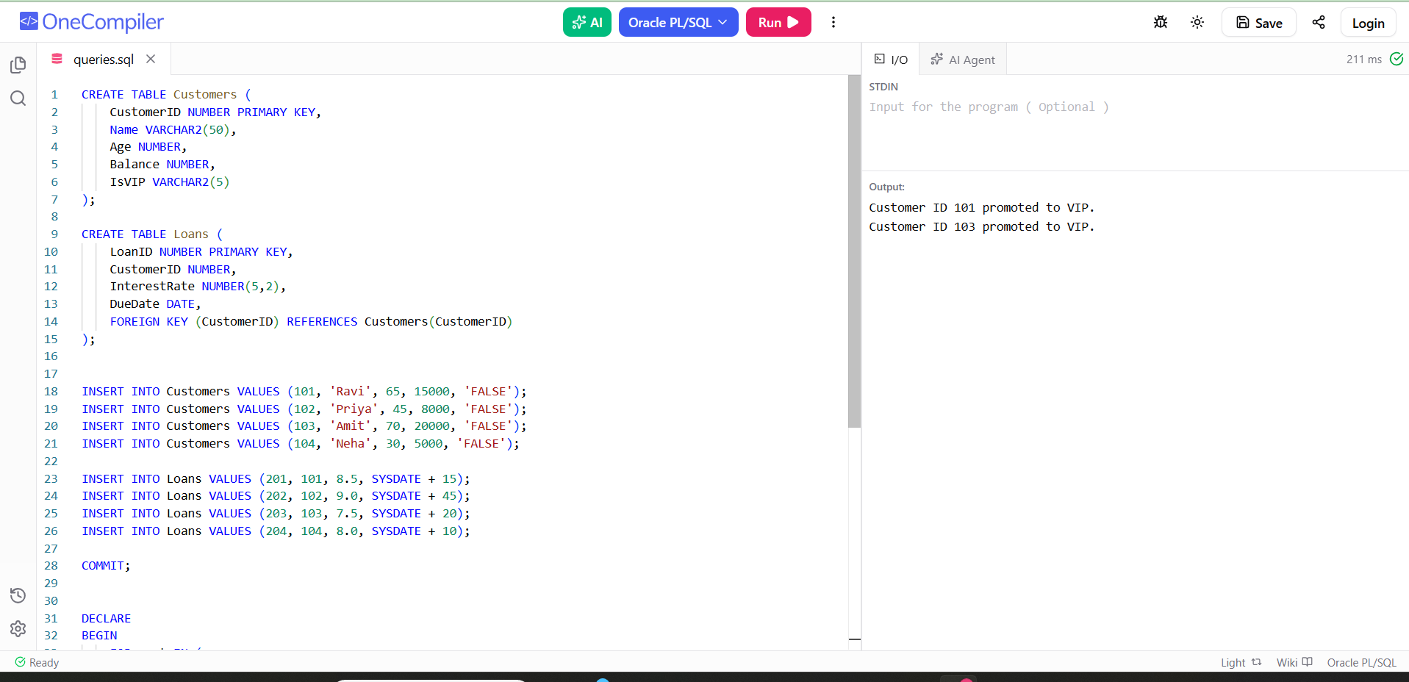

Scenario 3: The bank wants to send reminders to customers whose loans are due within the next 30 days.
  - Question: Write a PL/SQL block that fetches all loans due in the next 30 days and prints a reminder message for each customer.
Program Code:
DECLARE
BEGIN
FOR loan_rec IN (
SELECT c.CustomerID,
c.Name,
l.LoanID,
l.DueDate
FROM Customers c
JOIN Loans l
ON c.CustomerID = l.CustomerID
WHERE l.DueDate BETWEEN SYSDATE AND SYSDATE + 30
) LOOP
DBMS_OUTPUT.PUT_LINE(
'Reminder: Customer ' || loan_rec.Name ||
' (ID: ' || loan_rec.CustomerID || ')' ||
' has Loan ID ' || loan_rec.LoanID ||
' due on ' ||
TO_CHAR(loan_rec.DueDate, 'DD-MON-YYYY')
);
END LOOP;
END;
/
Output:
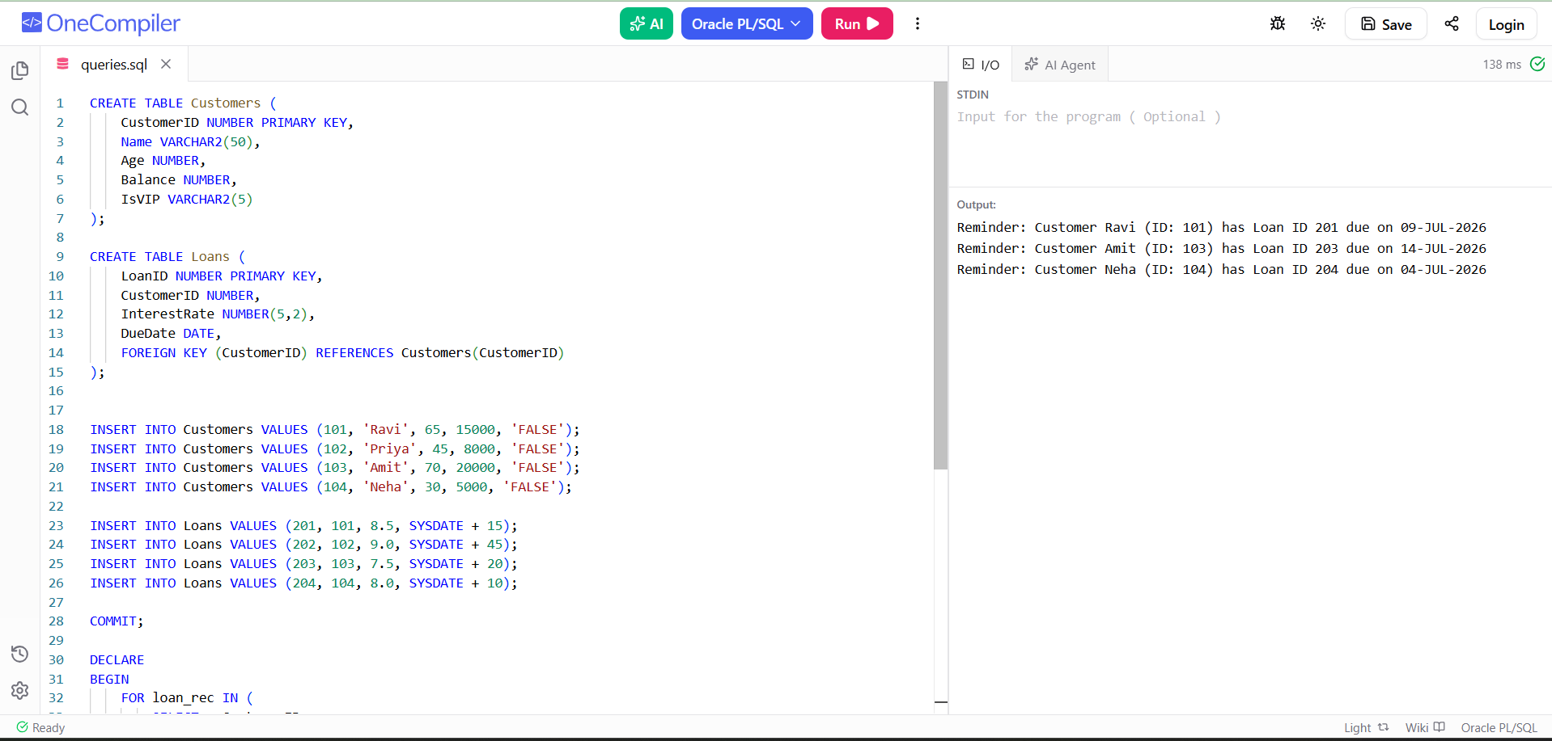

Exercise 3: Stored Procedures
Creating Tables:

Accounts Table:

CREATE TABLE Accounts (
AccountID NUMBER PRIMARY KEY,
CustomerName VARCHAR2(50),
AccountType VARCHAR2(20),
Balance NUMBER(10,2)
);

Employees Table:

CREATE TABLE Employees (
EmployeeID NUMBER PRIMARY KEY,
EmployeeName VARCHAR2(50),
Department VARCHAR2(30),
Salary NUMBER(10,2)
);

Inseting data:

Accounts Table:

INSERT INTO Accounts VALUES (101, 'Ravi', 'Savings', 10000);
INSERT INTO Accounts VALUES (102, 'Priya', 'Savings', 15000);
INSERT INTO Accounts VALUES (103, 'Amit', 'Current', 20000);
INSERT INTO Accounts VALUES (104, 'Neha', 'Savings', 12000);

COMMIT;

Employees Table:

INSERT INTO Employees VALUES (1, 'John', 'IT', 50000);
INSERT INTO Employees VALUES (2, 'Alice', 'IT', 60000);
INSERT INTO Employees VALUES (3, 'Bob', 'HR', 45000);
INSERT INTO Employees VALUES (4, 'Emma', 'HR', 55000);

COMMIT;

Scenario 1: The bank needs to process monthly interest for all savings accounts.
  - Question: Write a stored procedure ProcessMonthlyInterest that calculates and updates the balance of all savings accounts by applying an interest rate of 1% to the current balance.

Program Code:
CREATE OR REPLACE PROCEDURE ProcessMonthlyInterest
IS
BEGIN
UPDATE Accounts
SET Balance = Balance + (Balance * 0.01)
WHERE AccountType = 'Savings';

COMMIT;

DBMS_OUTPUT.PUT_LINE('=================================');
DBMS_OUTPUT.PUT_LINE(' MONTHLY INTEREST PROCESSING ');
DBMS_OUTPUT.PUT_LINE('=================================');
DBMS_OUTPUT.PUT_LINE('1% interest applied to all Savings Accounts.');
DBMS_OUTPUT.PUT_LINE('Balances updated successfully.');
DBMS_OUTPUT.PUT_LINE('Transaction Completed.');
END;
/

SET SERVEROUTPUT ON;

EXEC ProcessMonthlyInterest;

Output:

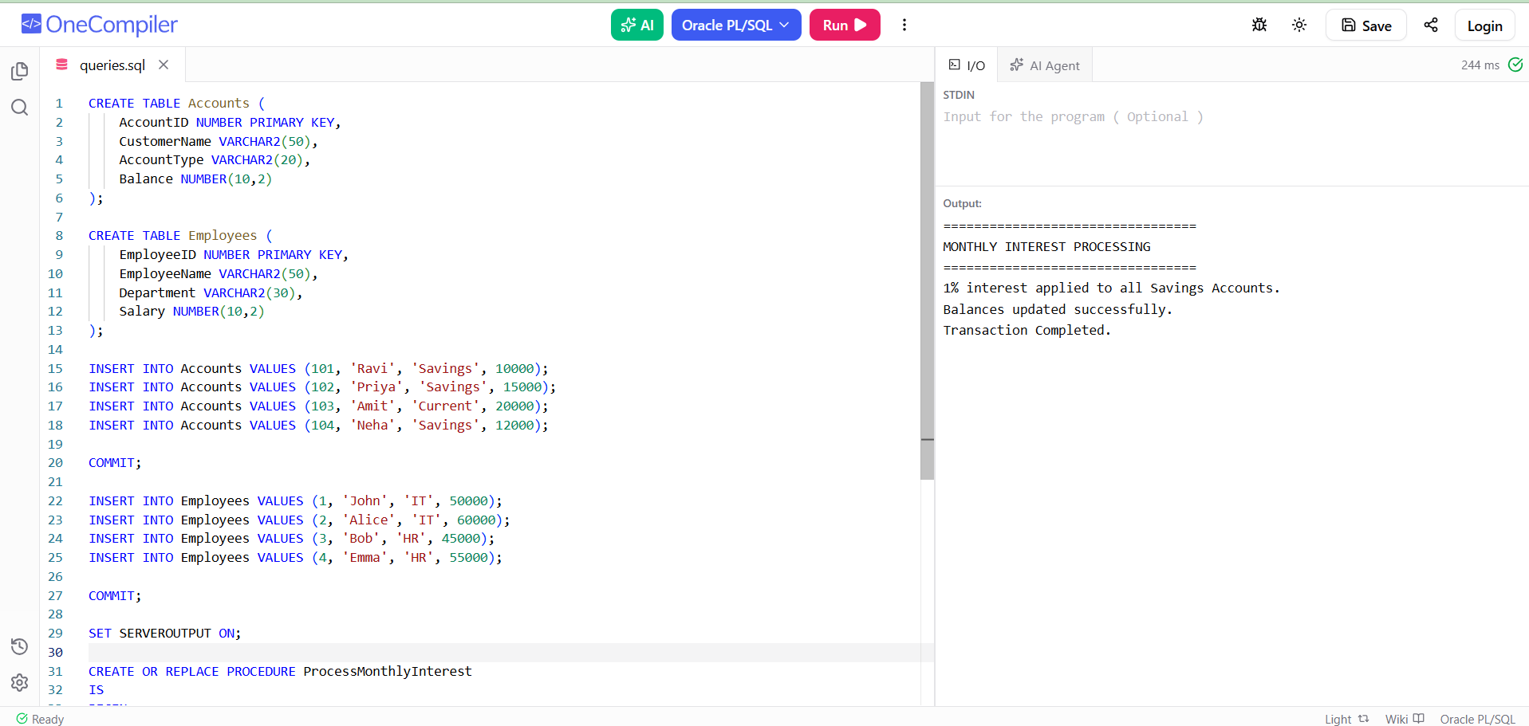

Scenario 2: The bank wants to implement a bonus scheme for employees based on their performance.
  - Question: Write a stored procedure UpdateEmployeeBonus that updates the salary of employees in a given department by adding a bonus percentage passed as a parameter.

Program Code:
CREATE OR REPLACE PROCEDURE UpdateEmployeeBonus(
p_department IN VARCHAR2,
p_bonus_percent IN NUMBER
)
IS
BEGIN
UPDATE Employees
SET Salary = Salary + (Salary * p_bonus_percent / 100)
WHERE Department = p_department;

COMMIT;

DBMS_OUTPUT.PUT_LINE('=================================');
DBMS_OUTPUT.PUT_LINE(' EMPLOYEE BONUS UPDATE ');
DBMS_OUTPUT.PUT_LINE('=================================');
DBMS_OUTPUT.PUT_LINE('Department : ' || p_department);
DBMS_OUTPUT.PUT_LINE('Bonus Added : ' || p_bonus_percent || '%');
DBMS_OUTPUT.PUT_LINE('Salary Updated Successfully.');
END;
/

EXEC UpdateEmployeeBonus('IT',10);

Output:

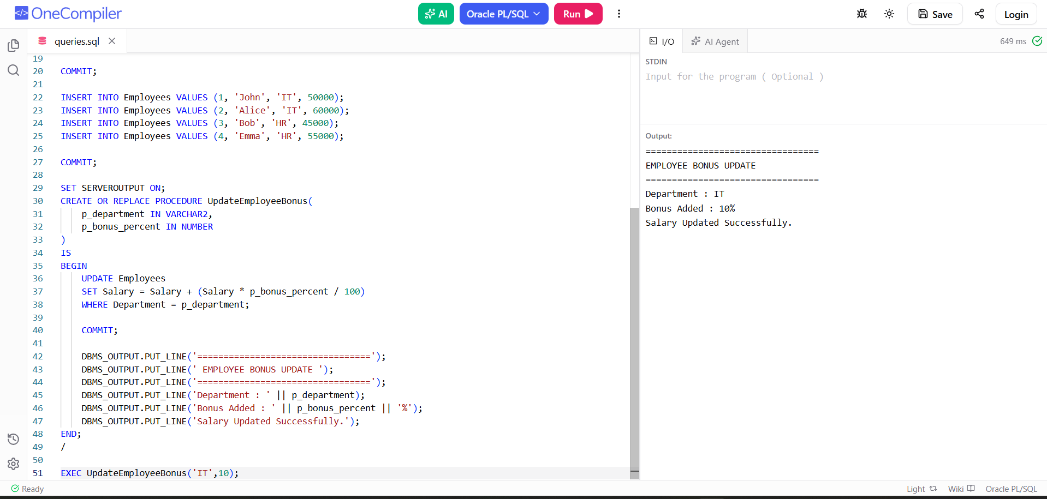

Scenario 3: Customers should be able to transfer funds between their accounts.
  - Question: Write a stored procedure TransferFunds that transfers a specified amount from one account to another, checking that the source account has sufficient balance before making the transfer.

Program Code:
CREATE OR REPLACE PROCEDURE TransferFunds(
p_from_account IN NUMBER,
p_to_account IN NUMBER,
p_amount IN NUMBER
)
IS
v_balance NUMBER;
BEGIN
SELECT Balance
INTO v_balance
FROM Accounts
WHERE AccountID = p_from_account;

IF v_balance >= p_amount THEN

UPDATE Accounts
SET Balance = Balance - p_amount
WHERE AccountID = p_from_account;

UPDATE Accounts
SET Balance = Balance + p_amount
WHERE AccountID = p_to_account;

COMMIT;

DBMS_OUTPUT.PUT_LINE('=================================');
DBMS_OUTPUT.PUT_LINE(' FUND TRANSFER SUCCESSFUL ');
DBMS_OUTPUT.PUT_LINE('=================================');
DBMS_OUTPUT.PUT_LINE('From Account : ' || p_from_account);
DBMS_OUTPUT.PUT_LINE('To Account : ' || p_to_account);
DBMS_OUTPUT.PUT_LINE('Amount : $' || p_amount);
DBMS_OUTPUT.PUT_LINE('Transfer Completed.');

ELSE
DBMS_OUTPUT.PUT_LINE('=================================');
DBMS_OUTPUT.PUT_LINE(' TRANSACTION FAILED ');
DBMS_OUTPUT.PUT_LINE('=================================');
DBMS_OUTPUT.PUT_LINE('Insufficient Balance.');
END IF;

EXCEPTION
WHEN NO_DATA_FOUND THEN
DBMS_OUTPUT.PUT_LINE('Invalid Account Number.');
END;
/

EXEC TransferFunds(101,102,2000);

Output:

